**TRIPLE THREAT +1**

**QR CODE VERIFICATION:**

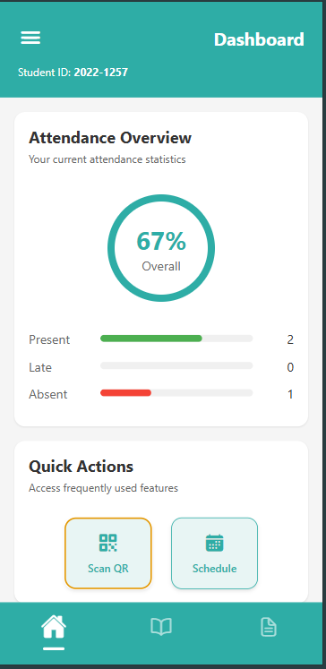

**QR CODE VERIFICATION SUCCESS:**

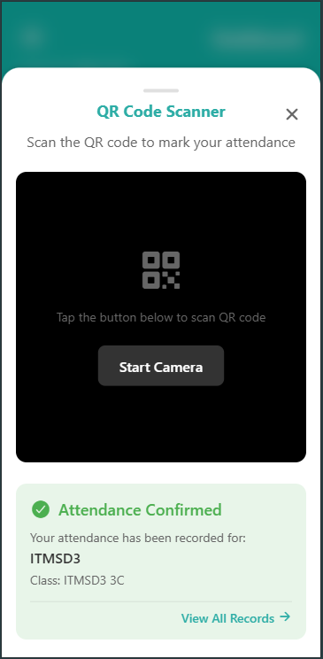

**ATTENDANCE RECORD:**

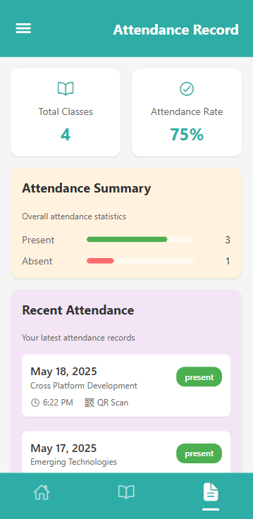

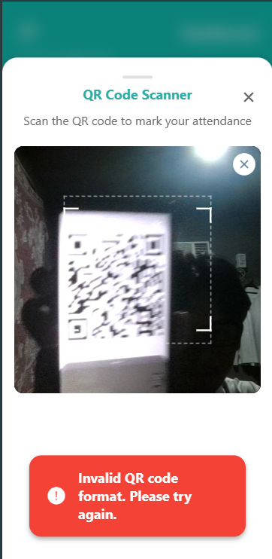**INVALID QR CODE:**